Ideation Phase
Define the Problem Statements

Date | 27 October 2026
Team ID:
Project Name | StaffSync
Maximum Marks | 2 Marks

Customer Problem Statement Template:
To define the core problems HR personnel, managers and employees face when managing HR processes manually, and use those insights to guide the development of StaffSync.
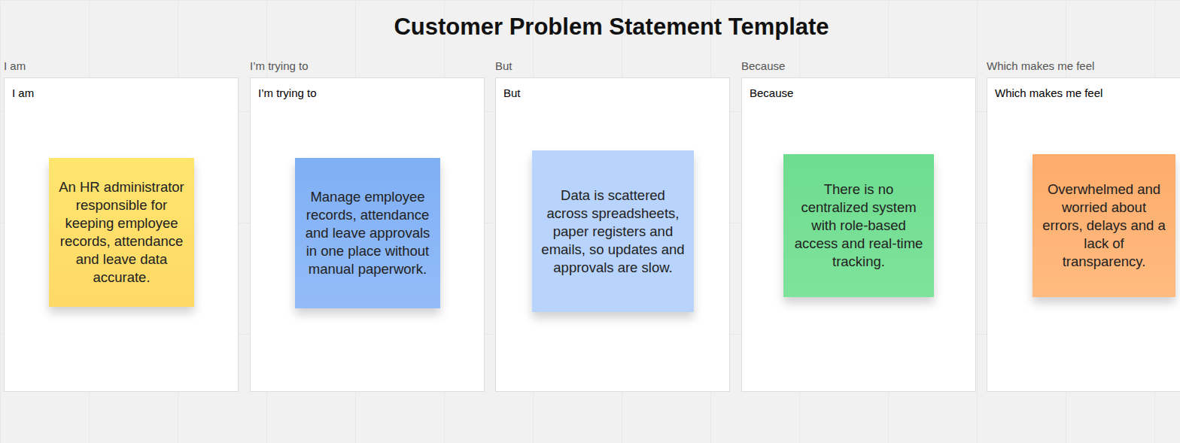
Reference: https://miro.com/templates/customer-problem-statement/

Problem Statement (PS) | I am (Customer) | I’m trying to | But | Because | Which makes me feel
PS-1 | HR manager | manage records, attendance and leave in one place | data is kept in files and emails | there is no centralized system with role-based access | overwhelmed and worried about errors, delays and a lack of transparency.
PS-2 | employee | apply for leave and mark attendance | I can't easily see my leave status | there is no digital platform with real-time updates | uninformed and frustrated by the delays.
PS-3 | team manager | review leave requests and manage team training | requests arrive through scattered emails and calls | there is no single dashboard for my team | stretched thin and unable to plan.

